Consensus report
Training
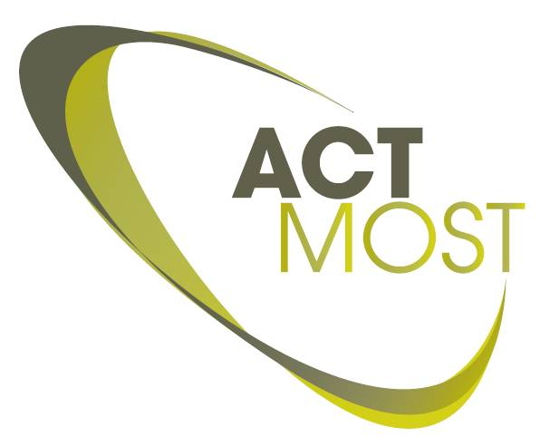

ACTMOST trainee responsible
Name of trainee responsible:
ACTMOST partner:
Tel: |  | fax:
email:

Company info
Name of the company:
Department :
Website:
 | Address: |  |  | Country:
 | Type of company: | Start-up SME Large-scale company
Comment: |  | [How big is the company in size of revenues or number of employees and when is the company founded]

Company contact PERSON
Name of contact person:
Title:
Tel: |  |  |  | fax:
email:

General training information
Title of the Training:

Involved ACTMOST partners :
Involved ACTMOST access centers
(first indicated access center is the main unit assigned to this project):

Consensus statements

[Show overview of the planned scope of training]

Has the scope of training been reached: Yes/No

In case answer is NO, provide an overview of the deviations and related reasons:

[Show overview of the planned training dates]

Has the training been performed on the foreseen dates? Yes/No

In case answer is NO, provide an overview of the deviations and related reasons:

[Show overview of the training contents and training duration for partner 1]

Is the training contents and duration by partner 1 performed as planned? Yes/No

In case answer is NO, provide an overview of the deviations and related reasons:

[Show overview of the training contents and training duration for partner 2]

Is the training contents and duration by partner 2 performed as planned? Yes/No

In case answer is NO, provide an overview of the deviations and related reasons:

[Show overview of the estimated budgets]

Are the costs for the partners and Company in line with the original budget? Yes/No

In case answer is NO, fill in tables below and explain the deviations:

ACTMOST partner 1 | Budget Real costs  Number of days [Copy from application form]  Personnel cost  Consumables cost  Total indirect cost  TOTAL for partner1  Cost carried by partner 1  Reason for deviations

ACTMOST partner 2 | Budget Real costs  Number of days [Copy from application form]  Personnel cost  Consumables cost  Total indirect cost  TOTAL for partner 2  Cost carried by partner 2  Reason for deviations

Summary: | Budget Real costs  Total cost of training [Copy from application form]  Support requested from ACTMOST  Total cost for company  Cost carried by partners

[Show overview of the impact on the company]

Is the expected impact on the company still valid? Yes/No

In case answer is NO, provide an overview of the new expected impact and related reasons:

[Show overview of the trainees]

Have all trainees followed the training sessions? Yes/No

In case answer is NO, provide an overview of the deviations and related reasons:

